Credit Shield: Identifying and Mitigating Loan Default Risk
Finance — Banking & Credit Risk

EXECUTIVE SUMMARY
Problem: Financial institutions suffer significant revenue loss when credit card borrowers default. Without behavioral early warning systems, banks can only respond after default — at which point recovery is expensive and often partial. The core question this project addresses: Which customers are most likely to default, which signals reveal that risk earliest, and what should the bank do about it?
Approach: The UCI Default of Credit Card Clients dataset — 30,000 customer records from Taiwan covering April–September 2005 — was processed through a five-notebook Python pipeline. Steps included baseline profiling, ETL cleaning with feature engineering, exploratory data analysis, formal statistical hypothesis testing, and Tableau-ready export. Four derived behavioral features (avg_delay, max_delay, utilization_ratio, risk_tier) were engineered to anchor both the statistical proofs and the five-view Tableau dashboard.
Key Insights:
- Payment delay is the single most powerful default predictor — defaulters' average delay deteriorated 177% over six months, from 0.26 to 0.72 months. Non-defaulters remained stable and near zero across the same window.
- Defaulters hold 27% less credit capacity than non-defaulters (NT$ 130,110 vs NT$ 178,100), confirmed at p = 6.13e-190 — one of the most statistically certain findings in the dataset.
- 9.56% of customers (2,868) are classified as High Risk but carry a ~42% default rate — nearly double the portfolio average of 22.12%.
- Both education level and marital status are statistically dependent on default outcome (chi-square confirmed), enabling structured demographic targeting.
Key Recommendations:
- Flag any customer whose avg_delay crosses 1.0 for immediate outreach — this is the behaviorally confirmed inflection point between Moderate and High Risk.
- Trigger a credit limit review for all customers with LIMIT_BAL below NT$ 100,000 AND utilization above 80%.
- Deploy targeted financial literacy programs for High School graduate customers — the highest-defaulting education segment.

SECTOR & BUSINESS CONTEXT
Sector Overview: Consumer credit in Asia expanded aggressively through the late 1990s and early 2000s. Taiwan's credit card market in particular experienced rapid saturation, with banks extending cards to increasingly marginal borrowers. This culminated in a retail credit default wave around 2005–2006 — the exact period captured by this dataset. The UCI data is not a theoretical exercise: it is a real record of a real credit crisis unfolding in real time. Today, the structural challenge of predicting and preventing retail credit defaults remains one of the highest-value unsolved problems in commercial banking globally.
Decision-Maker This Project Serves: Primary: Chief Risk Officer (CRO) and Head of Retail Credit at a commercial bank — responsible for portfolio-level risk policy, credit limit strategy, and capital allocation. Secondary: Credit operations managers and collections teams who need customer-level risk queues to prioritize outreach.
Why This Problem Was Chosen: Credit default carries a dual cost: direct revenue loss from unrecovered principal, and indirect cost from elevated regulatory capital requirements triggered by rising non-performing loan (NPL) ratios. At an average credit limit of NT$ 167,484 and a 22.12% default rate, this 30,000-customer portfolio has approximately 6,636 defaulted accounts. Even a 5% reduction in the default rate — achievable through targeted early intervention — would save over 330 accounts and protect roughly NT$ 55 million in exposed credit.
Business Value of Solving It: Shifting from reactive collections to proactive, data-driven risk segmentation means intervening before default materializes — through limit restructuring, payment plan offers, or financial counseling — at a fraction of the cost of post-default recovery. The cost of a proactive outreach call is estimated at NT$ 500–1,000. The cost of managing a defaulted account through collections and write-off exceeds NT$ 50,000–100,000. The economics of prevention are unambiguous.

PROBLEM STATEMENT & OBJECTIVES
Formal Problem Definition: Financial institutions face increasing loan defaults, leading to revenue loss and higher risk exposure. This project analyzes customer demographics, transaction behavior, and credit patterns to identify key factors driving loan defaults, segment high-risk customers, and recommend strategies to reduce default rates and improve risk management.
Core Business Question: What are the primary demographic and behavioral drivers of credit default, and how can we segment customers to proactively mitigate risk?
Decision Supported: Enable credit risk officers to adjust credit limits, intensify monitoring for high-risk segments, and refine lending criteria to reduce overall portfolio loss.
Scope:
- In scope: 30,000 credit card clients in Taiwan, 6-month repayment observation window (April–September 2005). Demographic analysis, behavioral payment signal analysis, rule-based risk segmentation, financial stress profiling, and Tableau dashboard design.
- Out of scope: Predictive ML model development, real-time data integration, geographic granularity below country level, and post-2005 macroeconomic conditions.

Success Criteria:
- Identification of top 3 behavioral and demographic default drivers, statistically validated at α = 0.05.
- Three-tier risk segmentation (High / Medium / Low) with measurably different default rates across tiers.
- 3–5 specific, actionable recommendations with estimated business impact.
- A five-view Tableau dashboard accessible to non-technical stakeholders.

DATA DESCRIPTION
Source: UCI Machine Learning Repository — Default of Credit Card Clients Dataset Contributed by: I-Cheng Yeh & Che-hui Lien (2009) Kaggle Mirror:Credit Card Clients Dataset
Dataset Structure:
- Rows: 30,000 (one row per customer)
- Columns: 25 original → 32 after cleaning and feature engineering
- Time Period: April 2005 – September 2005
- Geography: Taiwan
- Format: CSV

Key Column Groups:
Category | Columns | What They Capture
Credit Profile | LIMIT_BAL | Total credit limit issued (NT$)
Demographics | SEX, EDUCATION, MARRIAGE, AGE | Customer profile characteristics
Payment History | PAY_0 to PAY_6 | Monthly repayment delay status (-1 = paid duly, 1–8 = months overdue)
Bill Statements | BILL_AMT1 to BILL_AMT6 | Monthly outstanding bill amounts (NT$)
Payment Amounts | PAY_AMT1 to PAY_AMT6 | Actual monthly payments made (NT$)
Target Variable | default_status | Whether customer defaulted the following month (1=Yes, 0=No)

Engineered Features (Post-Cleaning):
Feature | Formula | Role
utilization_ratio | BILL_AMT1 / LIMIT_BAL | Financial stress indicator
avg_delay | mean(PAY_0 to PAY_6) | Primary behavioral default predictor
max_delay | max(PAY_0 to PAY_6) | Worst-case single month delay
risk_tier | Rule-based segmentation | High / Medium / Low risk classification

Data Limitations and Known Biases:
- Single country (Taiwan), single economic period (2005) — findings not directly generalizable to other markets.
- 22.12% default rate is atypically high by global standards — a reflection of Taiwan's credit crisis, not normal portfolio behavior.
- No income, employment, or geographic data — key socioeconomic context variables are absent.
- Undocumented categorical encodings in EDUCATION (values 0, 5, 6) and MARRIAGE (value 0) required judgment-based imputation.
- Class imbalance: 77.88% non-default vs 22.12% default — documented as a known dataset characteristic.

DATA CLEANING & ETL PIPELINE
All cleaning executed in Python. Notebooks committed to GitHub. Philosophy: preserve signal, document every decision, drop zero rows without written justification.
Notebook 01 — Extraction & Baseline Profiling Raw dataset loaded without modification. Confirmed: 30,000 rows, 25 columns, zero explicit nulls, zero duplicate rows. value_counts revealed undocumented encodings in EDUCATION (0, 5, 6) and MARRIAGE (0) — flagged as implicit missing values for treatment in Notebook 02. Class imbalance documented: 77.88% non-default vs 22.12% default.
Notebook 02 — ETL Pipeline & Feature Engineering
Step 1 — Drop ID column: Row identifier with no analytical value. Retained would introduce false correlations in downstream statistical tests.
Step 2 — Rename target column: default.payment.next.month → default_status. Dot notation in column names causes silent attribute access errors in Python.
Step 3 — EDUCATION implicit missing value treatment: Values 0, 5, 6 converted to NaN (~350 rows). Imputed using mode (value = 2, University). Mode is the correct imputation method for nominal categorical variables where mean and median are mathematically meaningless.
Step 4 — MARRIAGE implicit missing value treatment: Value 0 converted to NaN (~55 rows). Imputed using mode (value = 2, Single).
Step 5 — PAY column recode (-2 → -1): Value -2 is undocumented but interpreted as "no consumption that month." Converting to NaN would destroy 6 months of behavioral history. Recoded to -1 (pay duly) — the most conservative defensible interpretation.
Step 6 — Outlier audit (retain decision): IQR method identified extremes in LIMIT_BAL, BILL_AMT1, and PAY_AMT1. All outliers retained because: extreme credit limits represent genuine high-net-worth profiles (not data errors); high bill amounts are analytically critical for identifying the most financially stressed customers; removing outliers would introduce selection bias. Total rows retained: 30,000.
Step 7 — Negative BILL_AMT retained: Represent credit balances (customer overpaid). Valid financial states — not errors.
Step 8 — Feature engineering:
Feature | Formula | Business Meaning
utilization_ratio | BILL_AMT1 / LIMIT_BAL | What fraction of credit limit is currently consumed. Higher = more financially stretched. Zero-division handled.
avg_delay | mean(PAY_0 to PAY_6) | Average repayment behavior across 6 months — captures sustained patterns, not anomalies.
max_delay | max(PAY_0 to PAY_6) | Worst single month of delay — the behavioral floor of a customer.
risk_tier | Rule-based | High: max_delay ≥ 2 AND utilization > 80%; Medium: max_delay ≥ 1 OR utilization > 60%; Low: all others.
Step 9 — Label mapping: Readable Tableau labels created for sex_label, education_label, marriage_label, default_label. Numeric originals retained for statistical compatibility.
Final Dataset State:
Metric | Value
Rows | 30,000 (zero dropped)
Columns | 32 (after cleaning + feature engineering)
Missing values | 0
Output | cleaned_credit_data.csv

Notebook 05 — Tableau-Ready Export Added binned groupings: age_group (18–25, 25–35, 35–50, 50+), utilization_category (High/Medium/Low), delay_category (High Delay/Moderate Delay/No Delay). Final export: tableau_ready_dataset.csv — 30,000 rows × 32 columns.

KPI & METRIC FRAMEWORK
KPI | Formula | Business Meaning | Maps To
Default Rate | Defaults / Total Customers | Headline portfolio health metric | Problem Statement
High Risk % | High Risk Customers / Total | Share of portfolio under active default threat | Segmentation Objective
Avg Utilization | mean(BILL_AMT1 / LIMIT_BAL) | Financial stress — proximity to credit ceiling | Financial Behavior
Avg Delay | mean(PAY_0 to PAY_6) | Primary behavioral default predictor | Behavioral KPI
Max Delay | max(PAY_0 to PAY_6) | Worst-case behavioral signal — used in risk tier | Risk Tier Construction
Payment Gap | BILL_AMT1 − PAY_AMT1 | Unmet financial obligation — active stress measure | Financial Stress Dashboard
Average Credit Limit | mean(LIMIT_BAL) | Financial capacity baseline — lower = higher risk exposure | Capacity Analysis
% Late Customers | Customers with avg_delay > 0 / Total | Breadth of delay problem across the portfolio | Repayment Dashboard
Delay Score | Composite of PAY_0 to PAY_6 | Cumulative behavioral delay burden | Repayment Dashboard

EXPLORATORY DATA ANALYSIS
Trend Analysis — Repayment Delay Over Six Months The Pay Trend chart (Repayment Behavior Analysis dashboard) is the most important visual in the entire project. It shows two diverging behavioral trajectories across April–September 2005:
- Defaulters began April at an average delay of 0.26 months and steadily worsened to 0.72 months by September — a 177% deterioration.
- Non-defaulters began at −0.24 (paying ahead of schedule on average) and remained near −0.11 by September — near-flat across the entire window.
The divergence is not sudden. It is a gradual, detectable, measurable drift that begins at the very first observation month. Business implication: Default is not a surprise event — it is a behavioral trend that can be intercepted 2–3 months before it materializes.
Distribution Analysis — Credit Limits and Age LIMIT_BAL is right-skewed: the majority of customers hold credit limits below NT$ 200,000, with a small high-net-worth tail above NT$ 500,000. The average limit is NT$ 167,484. Age distribution: the 25–35 cohort is the largest customer segment (approximately 12,000+ customers), followed by 35–50. The 18–25 and 50+ segments are smaller but exhibit distinct risk profiles — 18–25 customers are lower in volume but carry material delay patterns.
Default Overview — Portfolio Snapshot From the Credit Risk Overview dashboard: 23,364 customers (77.88%) did not default. 6,636 customers (22.12%) defaulted. The risk tier distribution shows High Risk at approximately 2,868 customers, with Low Risk and Medium Risk each containing approximately 12,000–14,000 customers.
Default Rate by Demographics (Customer Risk by Demographics dashboard)
- By Education: High School graduates show the highest default rate (~27%), followed by University (~24%), Graduate (~20%), and Others (~5%). Higher formal education does not linearly protect against default — Graduate holders still default at meaningful rates.
- By Marriage: "Others" category highest (~26%), then Married (~24%), then Single (~21%).
- By Gender: Male customers default at ~24% vs Female at ~21%. Gap is present but modest.
- By Age: The 25–35 cohort dominates default volume simply due to its size. Default rates are relatively consistent across age groups, but the avg_delay vs default chart shows defaulters (status=1) consistently carry 2x+ higher average delay than non-defaulters across every age group.
Risk Tier Analysis (Behavioral & Segment Analysis dashboard) The three-tier classification cleanly separates default outcomes:
- High Risk: ~42% default rate
- Medium Risk: ~25–28% default rate
- Low Risk: ~8–10% default rate
High Risk (2,868 customers) is the concentrated intervention zone. Within High Risk, the 25–35 age group contributes the largest volume (~1,200+ customers).
Delay Category vs Default High Delay customers default at approximately 60–65%. Moderate Delay: ~30–35%. No Delay: below 10%. Delay category is the cleanest visual separator of default outcomes in the entire dataset — more discriminating than any demographic variable.
Financial Stress Analysis (Financial Behavior & Stress dashboard) KPIs: Avg Bill Amount NT$ 51,223 | Avg Payment Amount NT$ 5,664 | Avg Payment Gap NT$ 130,605.
Defaulters' average bill is approximately NT$ 46,000 against average payment of under NT$ 5,000. Non-defaulters show a smaller but still present gap, with meaningfully higher payments relative to their bills. The Financial Stress Scatter plot shows the Critical Risk zone — high utilization ratio (>1.0) combined with large positive payment gap — is densely populated with defaulters. Safe zone customers cluster at low utilization and near-zero payment gaps.
Correlation Summary (Spearman ranking from Notebook 04): avg_delay > max_delay > LIMIT_BAL (negative) > AGE > BILL_AMT1 > PAY_AMT1

STATISTICAL ANALYSIS
All tests at α = 0.05. Methodology chain: normality testing → test selection → execution → effect size → business interpretation.
Test 1 — Shapiro-Wilk Normality Testing LIMIT_BAL: p ≈ 0 → NOT normally distributed. AGE: p ≈ 0 → NOT normally distributed. Decision: Use non-parametric tests for all numerical comparisons. Financial data is inherently right-skewed. Applying t-tests to non-normal financial data produces invalid p-values — Shapiro-Wilk first is the correct methodology chain.
Test 2 — Mann-Whitney U: Credit Limit vs Default Status
- H₀: Defaulters and non-defaulters have the same credit limit distribution
- H₁: Defaulters have significantly lower credit limits
- Result: U = (reported) | p = 6.13e-190 | Effect size r = 0.2356
- Mean LIMIT_BAL — Defaulters: NT$ 130,110 | Non-Defaulters: NT$ 178,100 | Difference: NT$ 47,990 (27% lower)
- Conclusion: H₀ rejected with overwhelming confidence. Defaulters hold 27% less credit capacity. Credit limit is a statistically proven structural risk signal — not a proxy for demographics. Lower limit = tighter financial margin = higher default exposure.
Test 3
Chi-Square: Education Level vs Default
- χ² = 109.30 | p = 1.55e-23 | Cramér's V = 0.0575
- Conclusion: Education level and default status are statistically dependent. The association is structural, not random — mathematically justifying education-based segmentation in the dashboard and in Recommendation 3.
Chi-Square: Marital Status vs Default
- χ² = 31.41 | p = 1.51e-07 | Cramér's V = 0.0334
- Conclusion: Marital status and default are statistically dependent. Effect size is modest but relationship is real and structurally consistent.
Test 4 — VIF Analysis: PAY Column Multicollinearity All PAY_0 to PAY_6 VIF values < 5 (acceptable threshold). However, the six columns measure the same underlying concept — payment delay — across consecutive months, creating temporal redundancy even without high VIF. avg_delay was engineered as the dimensionality reduction solution: one robust behavioral signal replacing six monthly columns for dashboard and business use.
Consolidated Statistical Summary:
Factor | Test | p-value | Statistic | Key Finding
Credit Limit | Mann-Whitney U | 6.13e-190 | r = 0.2356 | Defaulters hold NT$ 47,990 less (27% lower)
Education Level | Chi-Square | 1.55e-23 | χ² = 109.30 | Education and default structurally dependent
Marital Status | Chi-Square | 1.51e-07 | χ² = 31.41 | Marital category affects default probability
PAY Columns | VIF | — | All < 5 | avg_delay engineered to reduce temporal redundancy

TABLEAU DASHBOARD DESIGN
Dashboard Objective: Enable two distinct audiences — executive leadership (portfolio-level risk snapshots) and operational risk teams (customer-segment drill-downs for intervention prioritization) — through a single, interconnected five-view dashboard.
Live URL: Tableau Dashboard Link

View 1: Credit Risk Overview
KPIs: Customers: 30,000 | Default Rate: 22.12% | Defaults: 6,636 | Avg Utilization: 42.38% | Avg Limit: NT$167,484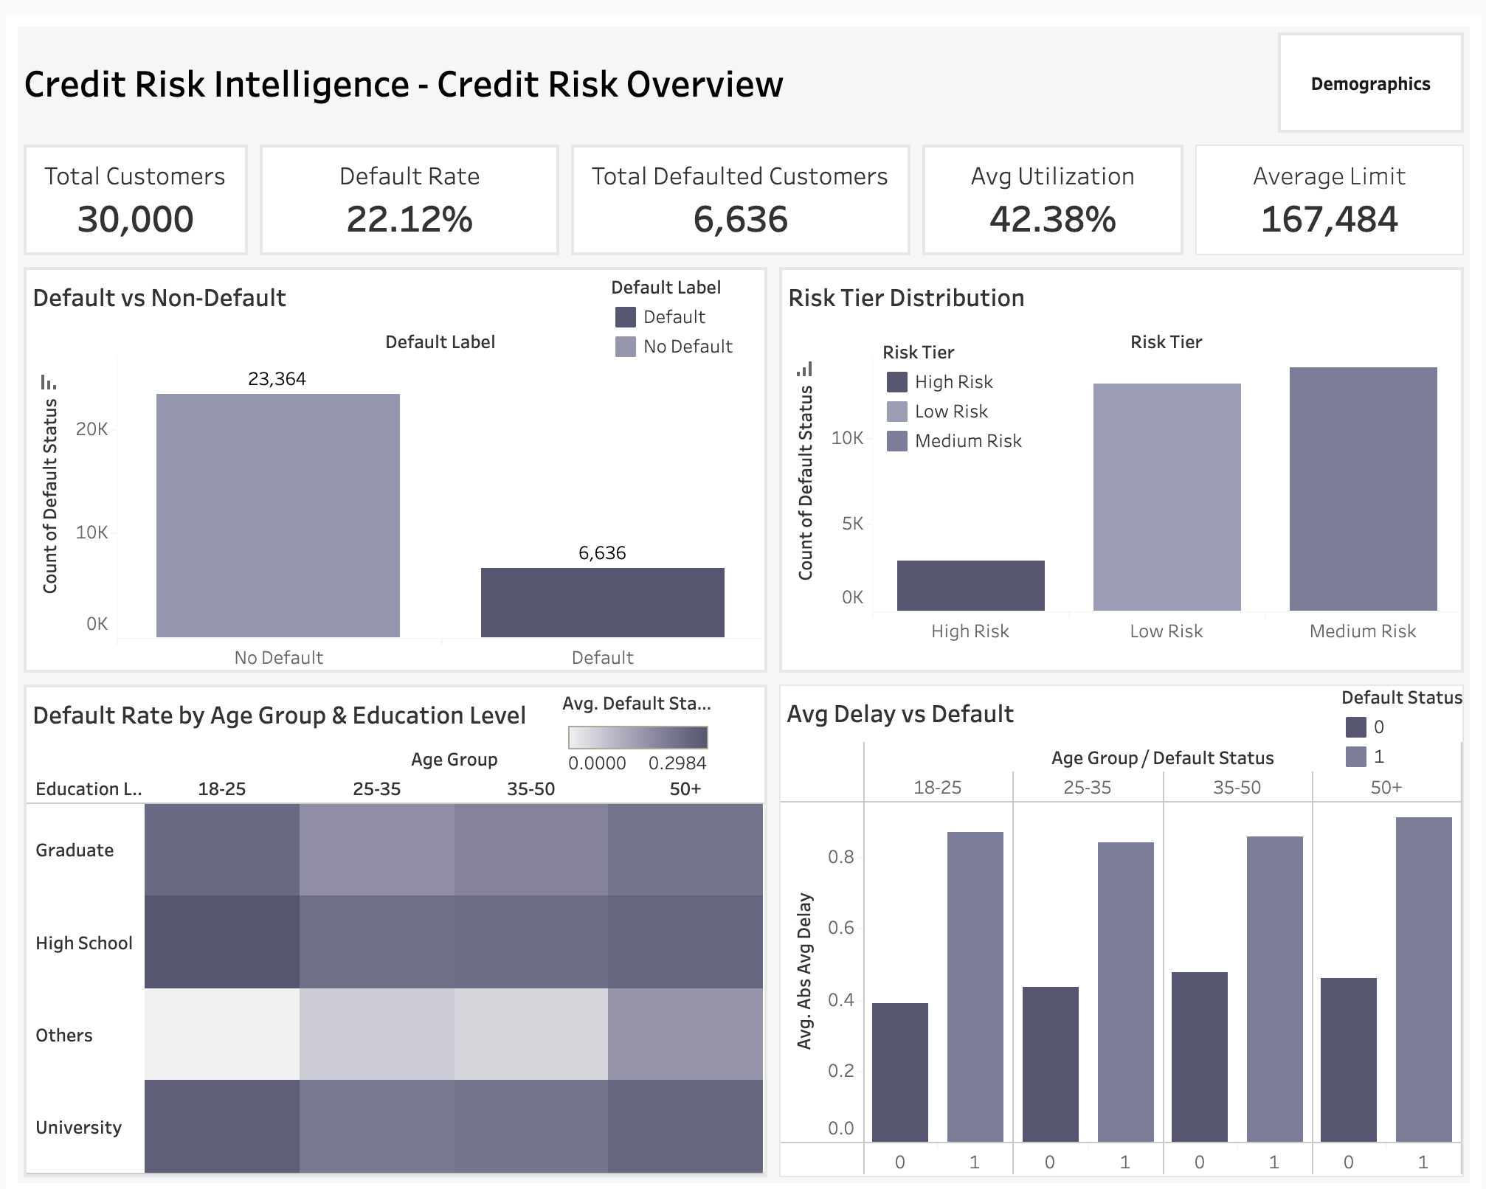
Insights:
- Clear split between default (6,636) and non-default (23,364).
- Risk tiers highlight distribution across High/Medium/Low segments.
- Age–education heatmap identifies highest-risk demographic clusters.
- Delay vs default shows rising delays linked to higher default risk.
Purpose: Snapshot of overall portfolio health and key risk concentrations.

View 2: Customer Risk by Demographics
KPIs: Same as above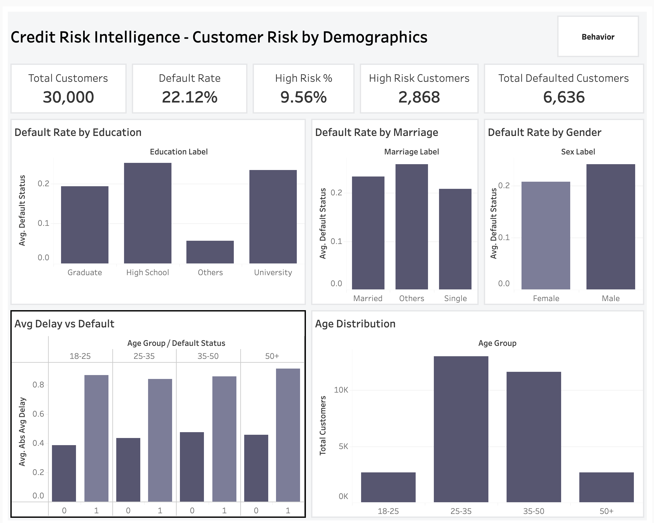
Insights:
- Higher default rates: High School (~27%), Married (~24%), Male (~24%).
- Lower risk: Graduates (~20%), Singles (~21%), Females (~21%).
- Age distribution and delay trends show risk variation across cohorts.
Purpose: Supports targeted policies and customer segmentation strategies.

View 3: Financial Behavior & Stress
KPIs: Utilization: 42.38% | Avg Bill: NT$51,223 | Avg Payment: NT$5,664 | Payment Gap: NT$130,605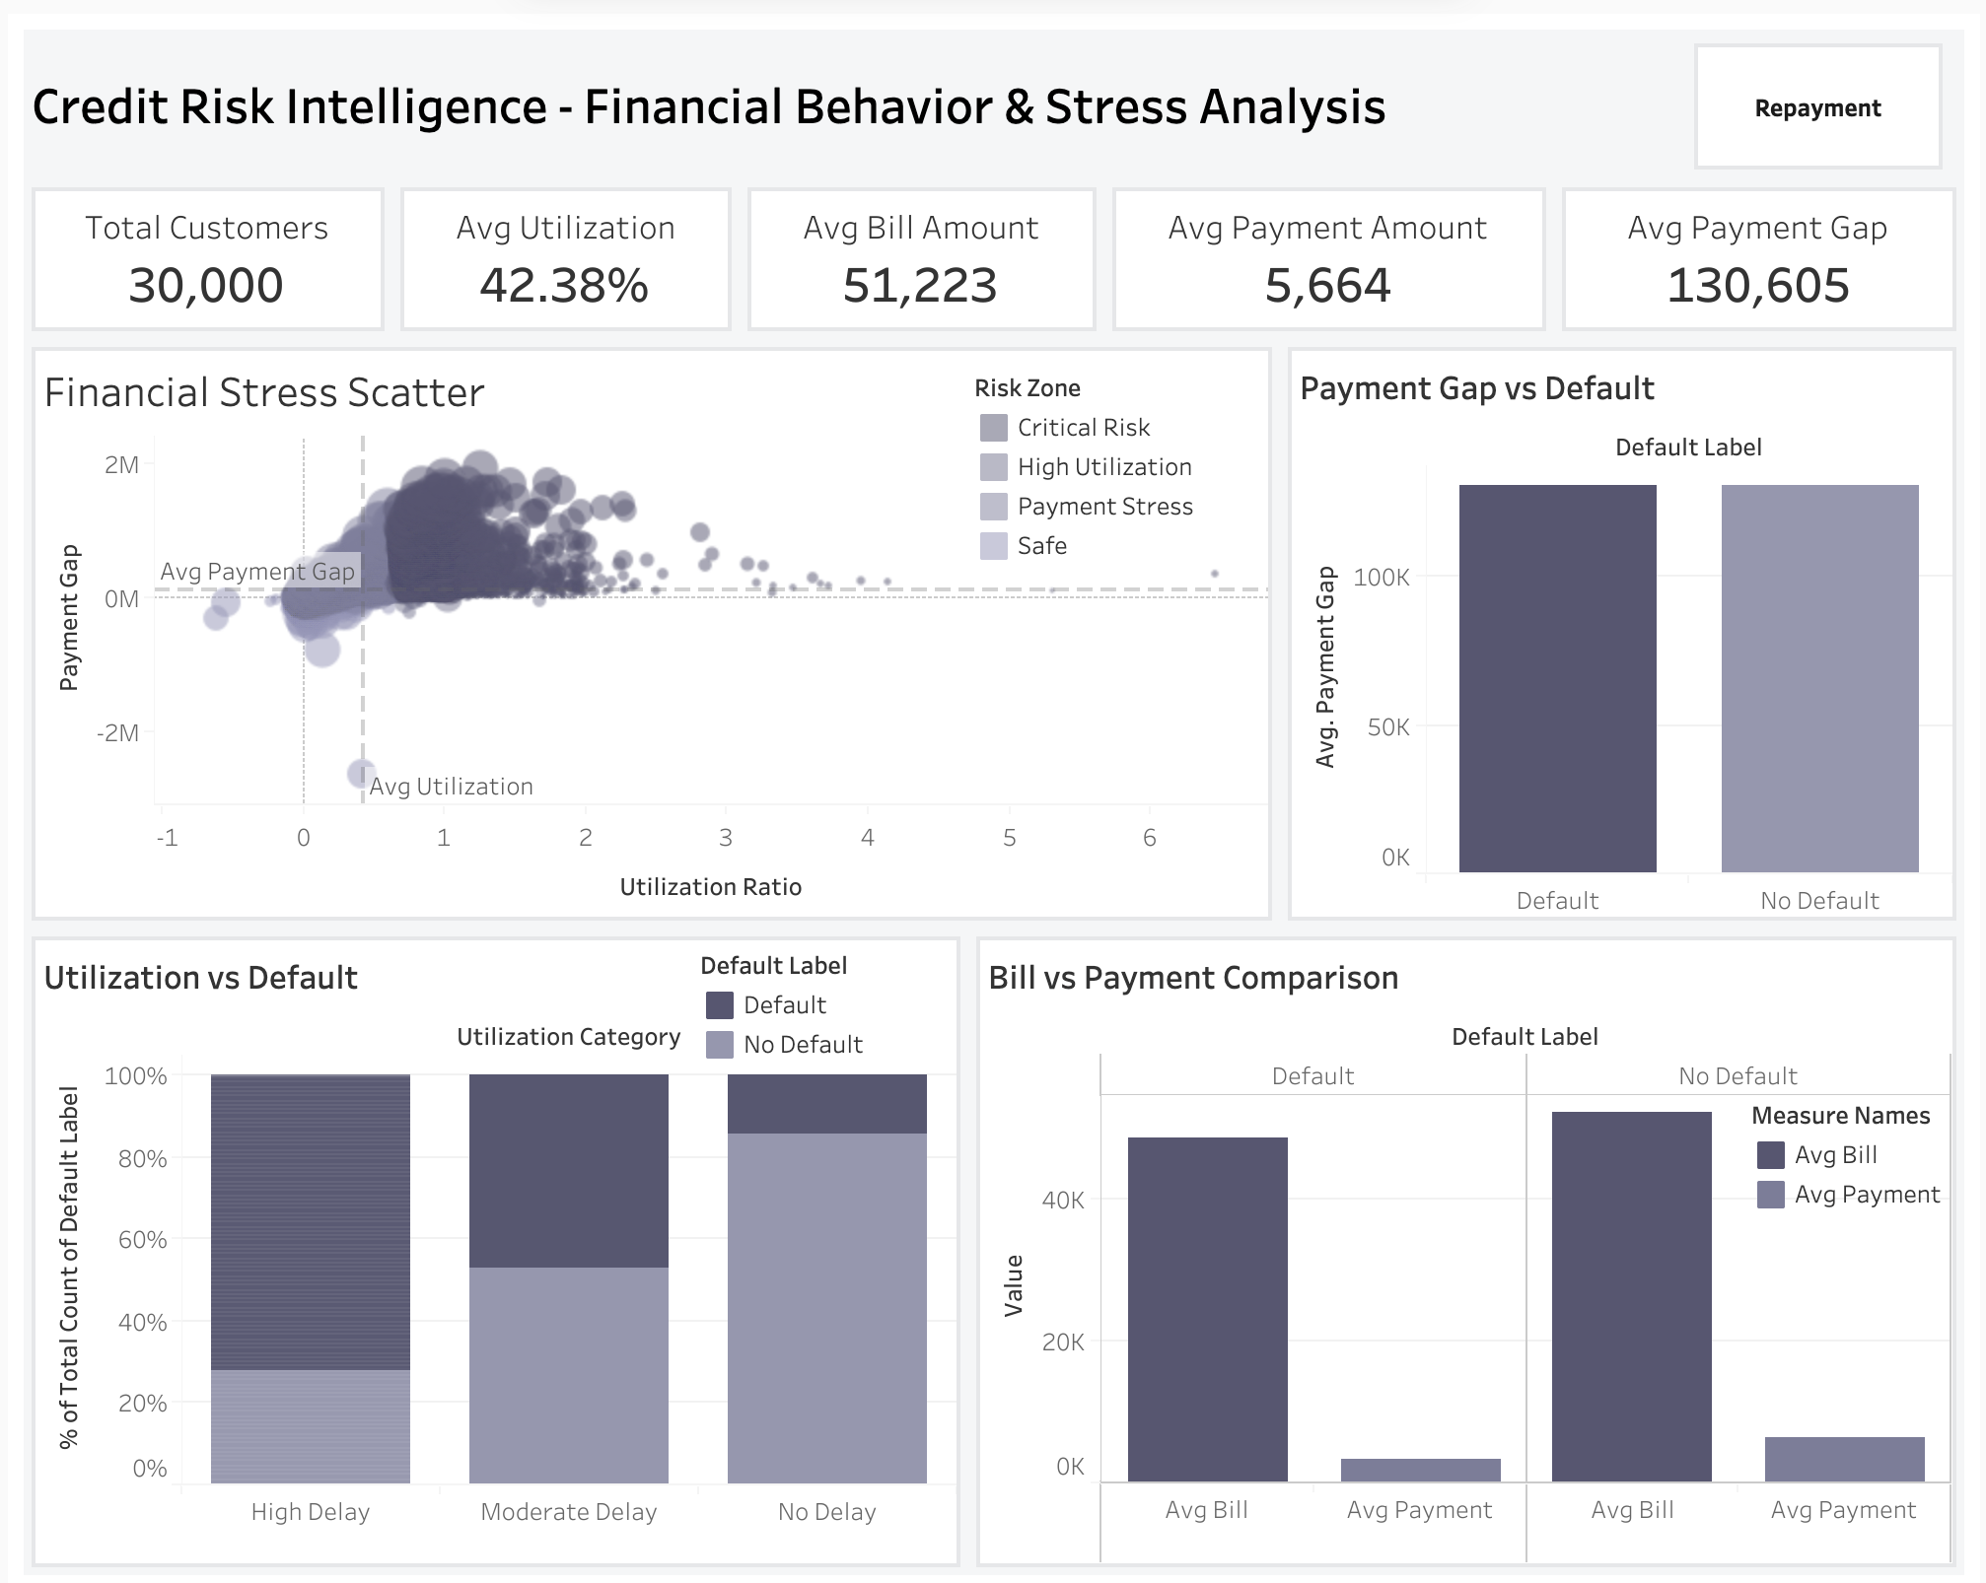
Insights:
- High utilization + large payment gap = Critical Risk zone.
- Defaulters show significantly higher payment gaps.
- Bills exceed payments consistently in default group.
Purpose: Identifies financially stressed customers for early intervention.

View 4: Repayment Behavior Analysis
KPIs: Avg Delay: 0.54 | Max Delay: 0.68 | Delay Score: 3.66 | Late Customers: 24.15%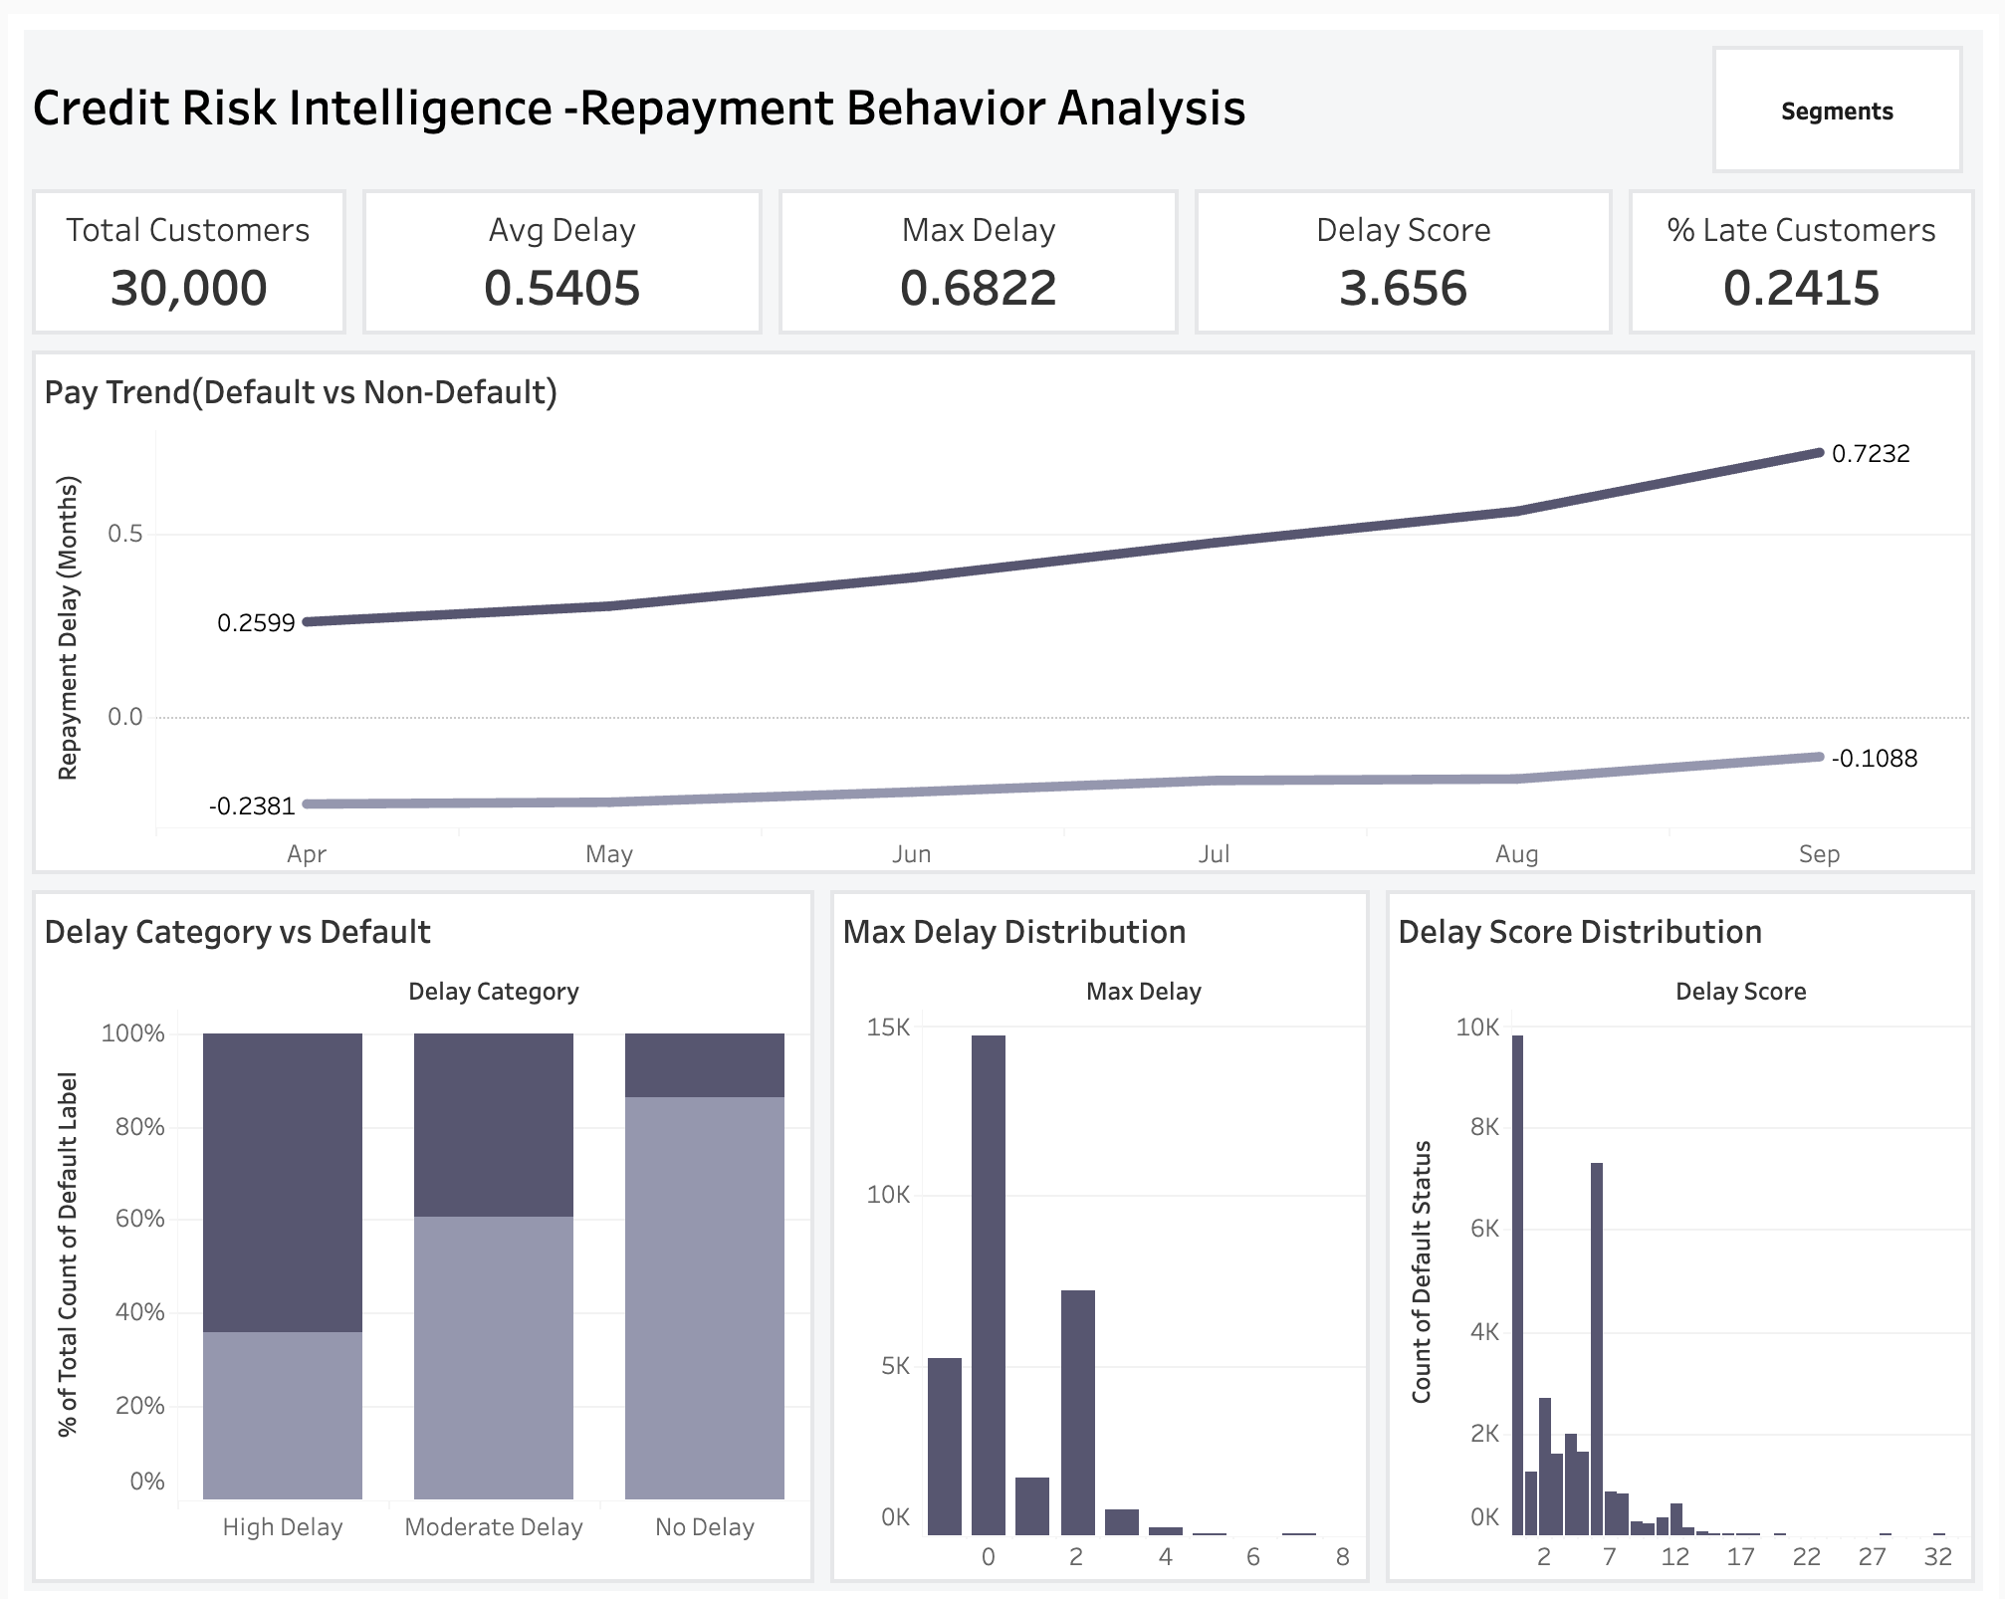
Insights:
- Strong divergence in payment trends between default vs non-default.
- Higher delays directly linked to default probability.
- Delay score distribution highlights risky accounts.
Purpose: Early warning system for operational action and collections.

View 5: Behavioral & Segment Analysis
KPIs: Customers: 30,000 | High Risk: 2,868 (9.56%) | Default Rate: 22.12% | Utilization: 42.38%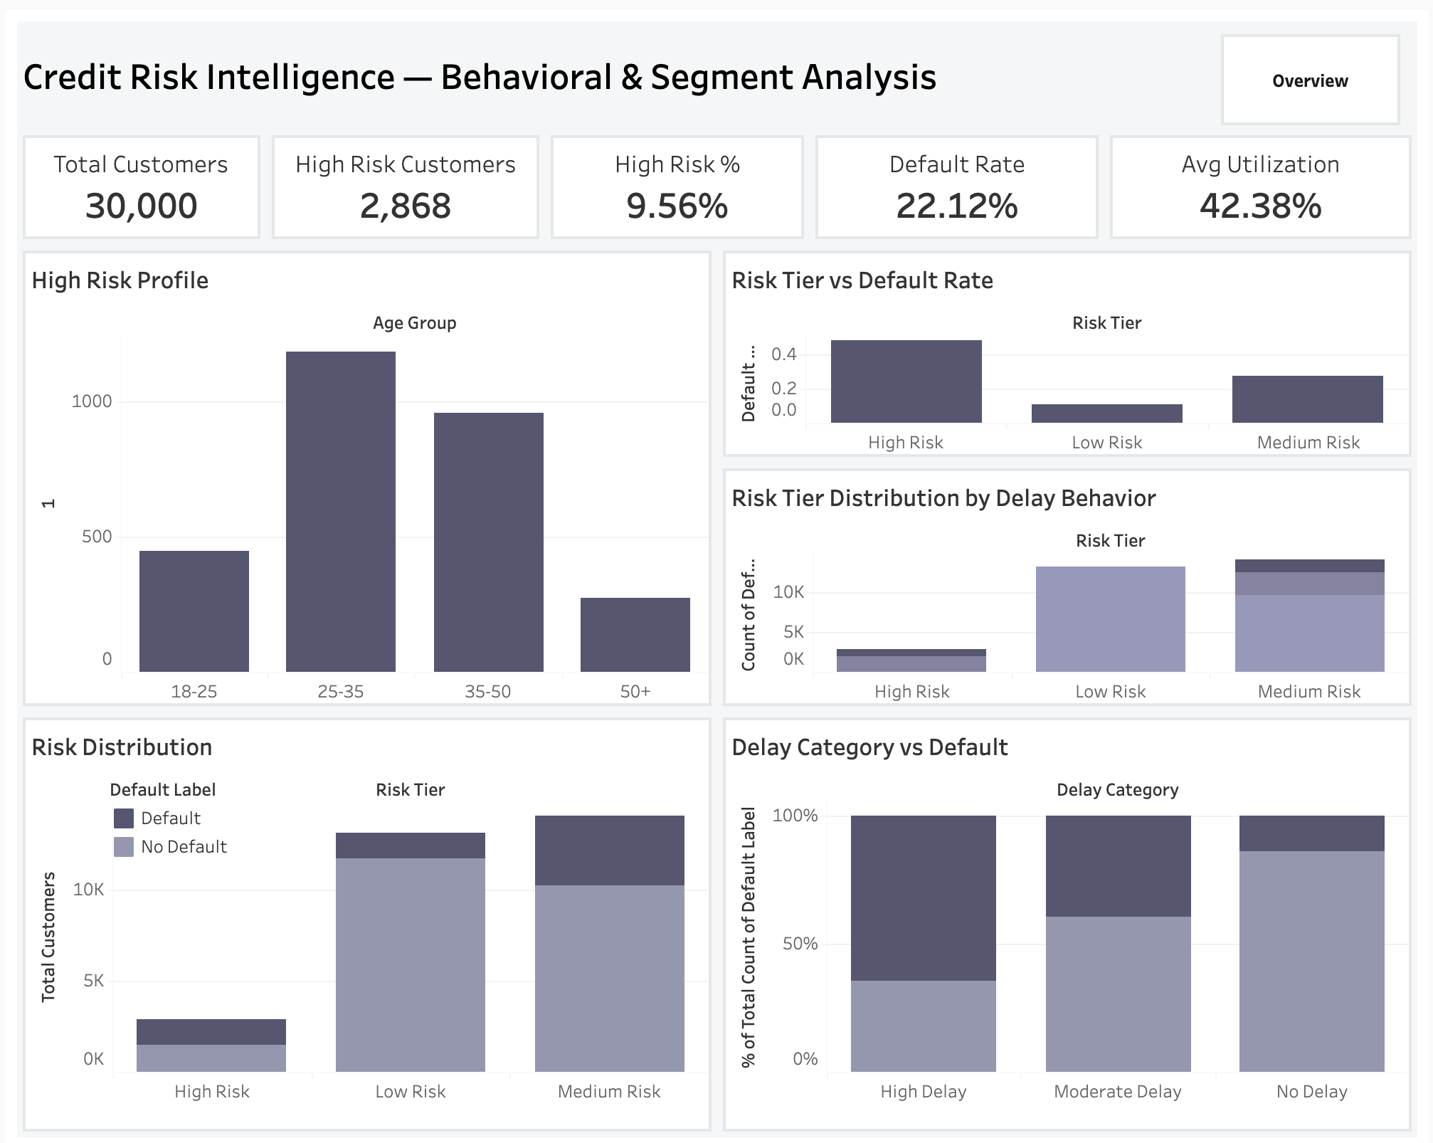
Insights:
- High-risk segments concentrated in specific age groups.
- Default rates increase sharply across higher risk tiers.
- Delay behavior strongly correlates with risk segmentation.
Purpose: Enables focused risk management and resource allocation.

Filters & Interactivity
- Navigation across all views
- Filters: Risk Tier, Delay Category, Default Status
- Consistent dataset: 30,000 customers across all views

INSIGHTS SUMMARY
Insight 1 — Default Is a Behavioral Drift, Not a Sudden Event Defaulters' avg_delay increased 177% over the six-month window — 0.26 months in April to 0.72 months in September. Non-defaulters stayed near −0.11 throughout. The behavioral separation is visible from Month 1. Banks that monitor this drift can intervene 2–3 months before default materializes.
Insight 2 — Payment Delay Is the Single Most Powerful Default Predictor in the Dataset avg_delay and max_delay are the top two Spearman-ranked features correlated with default_status, confirmed by Point-Biserial significance (p < 0.05). High Delay customers default at 60–65% — nearly 3x the portfolio average.
Insight 3 — Credit Limit Is a Risk Management Lever, Not Just a Product Variable Defaulters hold NT$ 130,110 vs NT$ 178,100 for non-defaulters — a NT$ 47,990 gap (27%) confirmed at p = 6.13e-190. Lower limit = tighter financial margin = higher default exposure. Credit limit policy directly determines default risk exposure.
Insight 4 — 9.56% of Customers Drive Disproportionate Portfolio Risk The 2,868 High Risk customers carry a ~42% default rate vs a 22.12% portfolio average. Concentrating intervention resources on this segment delivers the highest return on risk management investment.
Insight 5 — The 25–35 Age Cohort Is the Highest-Volume Risk Segment This is the largest customer group by count AND the largest within the High Risk tier (~1,200+ of the 2,868 High Risk customers). Early career financial stress combined with aggressive credit usage makes this the single highest-priority demographic for proactive outreach.
Insight 6 — High School Graduates Default at the Highest Rate of Any Education Segment At ~27% default rate, High School graduates outpace all other education categories, confirmed at χ² = 109.30, p = 1.55e-23. This structural relationship enables targeted prevention at the customer acquisition stage.

Insight 7 — The Payment Gap Reveals Hidden Financial Collapse The average defaulter carries NT$ 51,223 in bills against NT$ 5,664 in payments — a staggering imbalance. The average payment gap across the portfolio is NT$ 130,605. Customers in this position are not struggling — they are in structural financial free fall. Payment gap is an early stress signal that most standard credit monitoring systems miss.
Insight 8 — Utilization Above 80% Combined With Any Delay Triggers the Critical Risk Zone The Financial Stress Scatter confirms: high utilization AND large payment gap = Critical Risk. Customers in this zone are not at risk of defaulting — they are in active financial distress. Immediate intervention (not just monitoring) is required.
Insight 9 — Education and Marital Status Are Structurally Linked to Default — Not Noise Chi-square confirms both: Education (χ² = 109.30, p = 1.55e-23) and Marriage (χ² = 31.41, p = 1.51e-07). These are not random statistical fluctuations at n=30,000. They are structural risk differentials that credit policies should explicitly account for.
Insight 10 — Non-Defaulters Are Not Delay-Free — They Are Delay-Stable Non-defaulting customers show avg_delay of −0.24 in April, remaining near −0.11 by September — near-flat. The key differentiator between defaulters and non-defaulters is not whether delay occurs, but whether it escalates. Escalation detection, not delay detection, is the right monitoring objective.
Insight 11 — The High Risk Tier Default Rate (~42%) Is Nearly Double the Portfolio Average This is the operational definition of a concentrated risk pocket. Standard portfolio-wide policies miss this segment. Tier-based differentiated treatment is not optional — it is the primary lever available for reducing portfolio-level loss.
Insight 12 — Max Delay Score Distribution Shows Most Customers Cluster at Low Delay The Max Delay Distribution histogram shows the vast majority of customers at max_delay = 0 or 1. The tail at max_delay ≥ 2 is small but carries catastrophic default rates. This confirms that the High Risk tier, while small in number (9.56%), is extreme in behavior — and extreme in risk.

RECOMMENDATIONS
Recommendation 1 — Deploy an avg_delay Early Warning Trigger (Priority: Immediate)
Insight Driving It: Defaulters' avg_delay crosses 1.0 months before default materializes. This is the statistically confirmed inflection point between Moderate and High Risk tier behavior. The behavioral signal is visible 2–3 months before default.
Recommendation: Implement an automated flag in the credit monitoring system that triggers a risk review and proactive outreach when any customer's rolling avg_delay crosses 1.0. Outreach should offer payment plan restructuring — not collections escalation — to preserve the customer relationship and prevent the account from crossing into default.
Implementation Feasibility: Requires integration of the avg_delay calculation into the bank's monthly account review cycle. The logic is simple (rolling 6-month mean of payment delay codes) and can be implemented in any SQL or Python pipeline within one sprint.
Expected Business Impact: Even a 10% intervention success rate on the 2,868 High Risk customers = ~287 prevented defaults × NT$ 130,110 average defaulter limit = NT$ 37.3 million in protected portfolio exposure.
Recommendation 2 — Dynamic Credit Limit Review for High-Utilization, Low-Limit Customers (Priority: High)
Insight Driving It: Defaulters hold 27% lower credit limits than non-defaulters (NT$ 130,110 vs NT$ 178,100, p = 6.13e-190). Customers with LIMIT_BAL below NT$ 100,000 AND utilization above 80% are in the tightest financial margin position in the portfolio.
Recommendation: Conduct a quarterly credit limit review for this specific sub-segment. Two options: (a) a controlled limit increase for customers with otherwise stable payment history, which reduces utilization ratio and lowers their risk tier classification; or (b) a structured payment plan offer to reduce outstanding balance before delay escalates to default.
Implementation Feasibility: Requires a quarterly data pull from the credit risk dashboard filtered on LIMIT_BAL < NT$ 100,000 AND utilization_ratio > 0.8. The Tableau Financial Behavior & Stress dashboard already surfaces this segment.
Expected Business Impact: Reducing utilization below 80% for even a fraction of high-utilization, low-limit customers downgrades their risk tier from High to Medium, directly lowering the portfolio-level High Risk % (currently 9.56%) and reducing regulatory capital requirements.
Recommendation 3 — Targeted Financial Literacy Programs for High School Graduate Customers (Priority: Medium)
Insight Driving It: High School graduates default at ~27% — the highest of any education segment — confirmed at χ² = 109.30, p = 1.55e-23. This is a structural, not random, relationship.
Recommendation: Partner with financial wellness platforms or build in-app educational content at the credit onboarding stage specifically for this cohort. Focus areas: minimum payment consequences, utilization ratio management, and the compound cost of revolving credit balances. Consider mandatory financial health check-ins for newly acquired High School graduate customers in the 18–35 age range.
Implementation Feasibility: Low-cost. Digital financial literacy content can be delivered through existing mobile banking or card management apps. No new infrastructure required.
Expected Business Impact: A 2–3% reduction in the High School graduate default rate (~6,000+ customers in this segment) prevents 120–180 additional defaults per portfolio cycle — at near-zero marginal cost per customer reached.
Recommendation 4 — Operationalize the Repayment Behavior Dashboard as a Live Monthly Alert System (Priority: Medium)
Insight Driving It: The Pay Trend chart shows behavioral divergence from the very first observation month. This signal exists and is detectable — but only if monitoring is in place and refreshed regularly.
Recommendation: Convert the Repayment Behavior Analysis dashboard view from a retrospective analysis tool into a live monthly operational alert system. Configure threshold alerts at the customer level for avg_delay escalation (crossing 0.5 → 1.0 → 2.0 thresholds), with automatic case creation for the collections and relationship management teams.
Expected Business Impact: Moving from monthly retrospective reporting to live behavioral monitoring changes the intervention timeline from post-default to pre-default — the difference between prevention (NT$ 500–1,000 outreach cost) and recovery (NT$ 50,000–100,000+ collections cost).
Recommendation 5 — Adopt Risk Tier as a First-Class Credit Policy Variable (Priority: Strategic)
Insight Driving It: The three-tier rule-based segmentation produces default rates of ~42% (High), ~27% (Medium), and ~8–10% (Low) using only two behavioral features. This is a powerful, transparent, and explainable segmentation.
Recommendation: Embed risk_tier classification as a standard variable in the bank's credit policy framework. Differentiate: credit limit increase eligibility (Low Risk eligible, High Risk frozen), interest rate tiers, minimum payment requirements, and collections escalation thresholds. Uniform portfolio-wide policies implicitly subsidize high-risk customers — tier-based policies eliminate that cross-subsidization.
Expected Business Impact: Risk-based policy differentiation is the foundation of modern credit portfolio management. Industry benchmarks indicate tier-based pricing improves portfolio net interest margin by 0.5–1.5% and reduces NPL ratios by reducing the implicit risk pooling of heterogeneous customer segments.

IMPACT ESTIMATION
Recommendation | Basis | Estimated Impact
Early Warning Trigger (avg_delay > 1.0) | 10% prevention rate on 2,868 High Risk customers × NT$ 130,110 avg limit | NT$ 37.3M protected exposure
Credit Limit Review (high utilization, low limit) | Reducing utilization below 80% for high-stress segment | Lowers portfolio High Risk % from 9.56%; reduces regulatory capital requirements
Financial Literacy (High School graduates) | 2–3% default rate reduction on ~6,000+ segment customers | 120–180 fewer defaults per cycle at near-zero marginal cost
Live Behavioral Monitoring | Prevention vs recovery cost differential (NT$ 1,000 vs NT$ 75,000 per account) | 75x ROI on outreach vs collections per saved account
Risk Tier Policy Differentiation | Industry benchmark: tier-based pricing improves NIM 0.5–1.5% | Long-term portfolio profitability improvement + NPL ratio reduction
Why Act Now: The current 22.12% default rate is more than double the ~10% typical for well-managed retail credit portfolios. Every month without an early warning system is a month of preventable defaults materializing into write-offs. The behavioral signals are already in the data. The intervention infrastructure requires only operationalization of what the analysis has already proven

LIMITATIONS
Data Limitations:
- Single country (Taiwan), single economic period (2005) — findings reflect a credit crisis environment, not typical portfolio conditions. All thresholds and benchmarks would need recalibration for other markets.
- No income, employment status, or geographic data — critical socioeconomic context is absent, limiting the precision of demographic profiling.
- 22.12% default rate is atypically high — any risk thresholds derived here (e.g., avg_delay > 1.0) would need validation against the target portfolio's baseline default rate before deployment.
- Six-month observation window — longer behavioral history would improve the stability and predictive power of engineered features.
Methodological Limitations:
- The risk_tier classification is rule-based, not statistically optimized — thresholds (max_delay ≥ 2, utilization > 80%) are analytically defensible but not derived from optimization. A logistic regression or decision tree could potentially find better boundaries.
- Class imbalance (77.88% vs 22.12%) was documented but not corrected — acceptable for EDA and statistical analysis, but would require SMOTE or resampling before any predictive model training.
- Chi-Square effect sizes (Cramér's V = 0.03–0.06) indicate small-to-modest practical association despite extreme statistical significance. At n = 30,000, even tiny real differences produce very small p-values. Statistical significance does not imply large practical effect.

What Cannot Be Concluded:
- Causation cannot be established — correlation between education level and default does not mean education causes default risk. Unobserved confounders (income, employment) are the more likely causal pathway.
- This analysis identifies which segments are at statistically higher risk — not which specific individual customers will default.
- Findings from Taiwan 2005 cannot be directly applied to other geographies or time periods without re-validation.

FUTURE SCOPE
1. Predictive Model Development A logistic regression, Random Forest, or XGBoost classifier trained on avg_delay, utilization_ratio, LIMIT_BAL, max_delay, and demographic features could move from segment-level risk profiling to individual-level default probability scoring — enabling customer-specific risk scores rather than tier buckets.
2. Real-Time Data Integration Connecting the Tableau dashboard to a live credit card transaction database would transform this from a retrospective analysis into an operational real-time early warning system — updating delay scores and utilization ratios on a daily or weekly basis.
3. Expanded Data Sources Adding income, employment status, credit bureau scores, and geographic data would substantially enrich the risk model. These variables are the most likely causal drivers of the demographic patterns currently observed.
4. SMOTE / Resampling for Predictive Modeling The 22.12% vs 77.88% class imbalance would require synthetic minority oversampling (SMOTE) or class-weighted training before any classifier is built — to prevent the model from learning to predict "no default" for all customers and achieving 78% accuracy while being operationally useless.
5. Longitudinal Cohort Analysis Extending the observation window to 12–24 months would reveal whether the behavioral deterioration patterns observed here are consistent across credit cycles or specific to the 2005 Taiwan environment. Longer histories also improve avg_delay and max_delay stability as risk predictors.

CONCLUSION
This project set out to answer a concrete banking question: who is most likely to default, and what signals reveal that risk before it materializes? The analysis of 30,000 credit card customers across six months of repayment history provides a clear, statistically validated, and operationally actionable answer. Payment delay is not a lagging outcome — it is a leading behavioral signal that diverges between defaulters and non-defaulters from the very first observation month and deteriorates 177% before default occurs. Credit limit acts as a structural protection factor, separating defaulters (NT$ 130,110) from non-defaulters (NT$ 178,100) with a confidence level of p = 6.13e-190. And 9.56% of customers — classified as High Risk through a transparent, rule-based tier system — carry a ~42% default rate that is nearly double the portfolio average and demands concentrated, immediate intervention. The recommendation to any credit risk team reviewing this analysis is direct: deploy behavioral monitoring now, act on avg_delay before it crosses 1.0 months, make risk tier a first-class variable in credit policy, and stop treating a 22.12% default rate as a fixed cost of doing business. The data shows it is not. It is a preventable loss — with the right signals, the right monitoring, and the will to act early.

APPENDIX
- Data Dictionary Full column definitions, derived feature logic, and data quality notes — see docs/data_dictionary.md in the GitHub repository.
- Additional EDA and Dashboard Visuals
  - Financial Stress Scatter Plot (Financial Behavior & Stress Analysis view)
  - Pay Trend: Default vs Non-Default (Repayment Behavior Analysis view)
  - Max Delay Distribution and Delay Score Distribution histograms
  - All available in the live Tableau dashboard and in notebooks/03_eda.ipynb
- Statistical Test Full Outputs Complete Shapiro-Wilk, Mann-Whitney U, Chi-Square, VIF, Point-Biserial, and Spearman outputs — see notebooks/04_statistical_analysis.ipynb in the GitHub repository.
- Pipeline Documentation Five-notebook reproducible pipeline — see reports/notebook_pipeline_analysis.md.
- Python Dependencies See requirements.txt in the repository root. Core stack: Python 3.12, Pandas, NumPy, SciPy, Seaborn, Matplotlib, Statsmodels.

CONTRIBUTION MATRIX

Team Member | Dataset &amp; Sourcing | ETL &amp; Cleaning | EDA &amp; Analysis | Statistical Analysis | Tableau Dashboard | Report Writing | PPT
Shaik Junaid Sami
Kartik Mehra
Mansi Agarwal
Yogesh Modi
Keshav Goyal

